****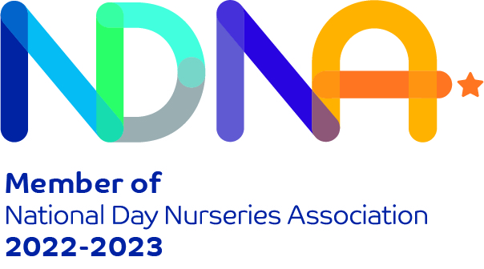

**March**

**2023**

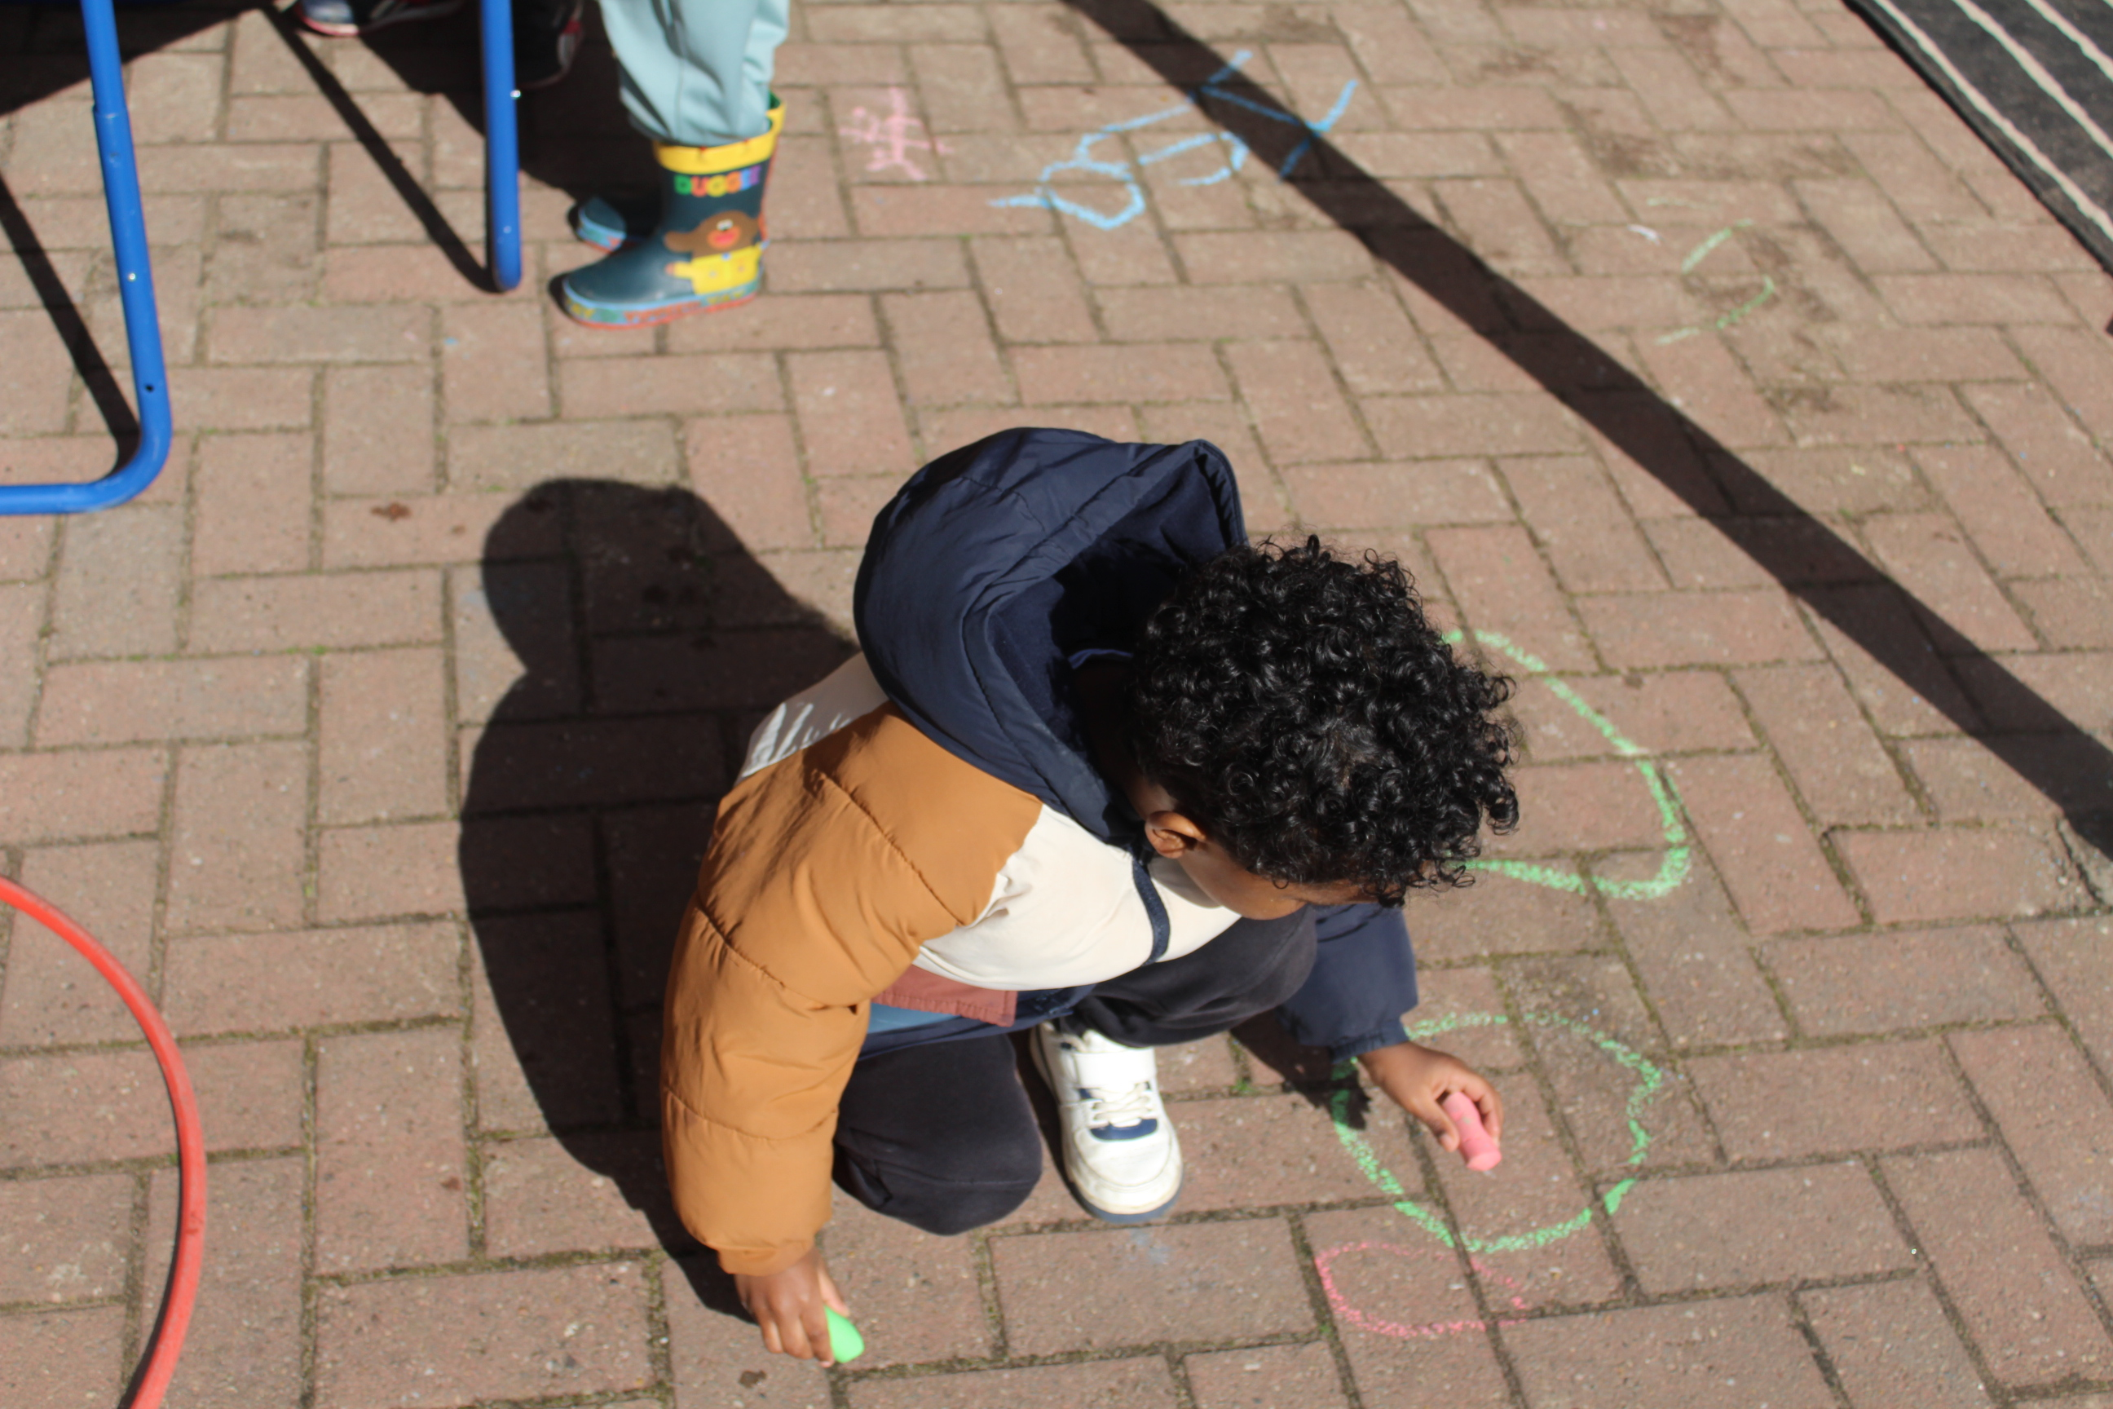

As the weather is picking up children enjoy spending more time in the outdoors.

**We wish our parents a Happy Easter!**

**Lunch Fee:**

A gentle reminder for parents to pay their weekly lunch fees of £3.75 in the office. This is used to pay for lunch, snack and ingredients for cooking activities.

Some children in preschool and toddlers recently attended a shopping trip, they thoroughly enjoyed the experience and enjoyed speaking about it when they came back!

**Parent Workshops**

Thank you to the parents who have attended our parent workshops so far. We are currently holding workshops with our parents, please speak to your key workers for more information.

**We close for end of term on Friday 31st March**

**We re-open on Monday 17th April 2023**

**We wish our parents a Ramadhan Mubarak!**

We hope you have a blessed Ramadhan!

**Nursery Website:**

www.hmbirds.com

Please like our page on Facebook!